«FundraiserName»

Dear Parents and Participants,

Here is the information you need to know about our upcoming fundraiser.

To help you with your financial needs, we are selling the exclusive Butter Braid Pastry! It can not be bought in any retail store, only through you! (The concept is like girl scout cookies…you know what box you would buy.) Just think of it, customers coming back year after year asking you when you are going to run again… Now that is FUNdrai$ing!

We sell the product for $16 and our group will earn 40% from each pastry that we sell. There is no sorting on our part as the delivery comes pre-sorted with your name on it ready to go. Sounds like an EZ Fundraiser with an amazing product.

If you are not familiar with the product or flavors, you can go visit www.ezfundraisingutah.com for more great info. See the products and download the pictures to use in your posts. Let the product sell itself. It looks and tastes delicious.

Now your plan…. “I hope I do well” …. HOPE is not a plan. Plan who you are going to contact and how many you want to sell. Just invite others to support you and you will be surprised how many do. This frozen pastry will bring a great experience to all in their homes.

Thank you for doing your part to make this fundraiser a success!

«ContactFirstName» «ContactLastName»
«ContactEmail»

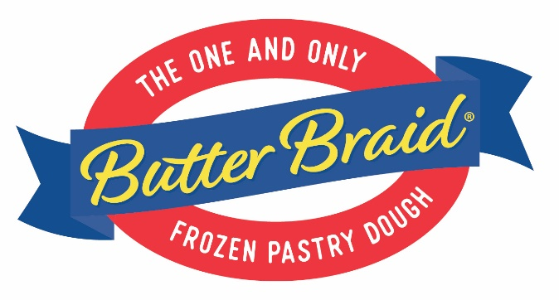
Important Details to Remember!
Fundraiser Purpose: | «FundsFor»
Individual Goal: | «MinimumPerSeller»
Group Goal: | «GroupProfitGoal»
Fundraiser Starts: | «StartOn»
Fundraiser Ends: | «ReturnOrderOn»
Delivery Date & Pickup Time: | «DeliveryOnformatted» From «DeliveryPickupAtformatted» to «DeliveryPickupEndAtformatted»

